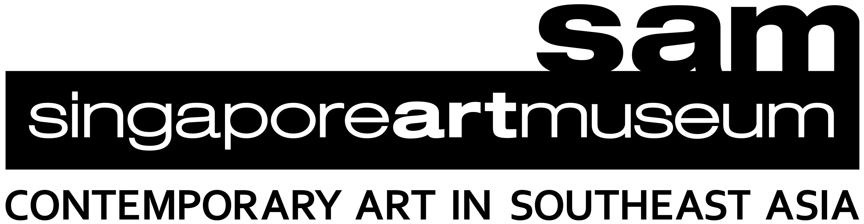

SAM TOUCH COLLECTION WORKSHOP BOOKING FORM

- Booking requests should be made at least 5 weeks prior to visit.
- Email this form to access@singaporeartmuseum.sg.
- Please refer to the following documents as you plan your visit
  - Venue Accessibility - Wayfinding to SAM at Tanjong Pagar Distripark

Contact Details
Name of Organisation | Click or tap here to enter text.
Name of Coordinator | Click or tap here to enter text.
Contact Number | Click or tap here to enter text.
Email address | Click or tap here to enter text.
☐ I wish to join the mailing list to receive invitations to Access programmes in the future.
☐ I wish to join the SAM mailing list to receive news and invitations on upcoming programmes and exhibitions.

Name of person-in-charge during visit  (if different from Coordinator) | Click or tap here to enter text.
Contact Number | Click or tap here to enter text.
(This is needed for coordination should the group encounter problems en route to, or while, at the location of programme). If needed, please contact SAM Access at 6697 9772)

Visit Date and Time request
Please suggest 2 dates for your visit. All workshops are held from 10.30am - 12.30pm. SAM Access will get in touch with you after the submission of this form. The workshop is not confirmed until you have received a confirmation email.
1st Choice:
Day and Date of visit | Date: ________
 | ☐ Monday ☐ Wednesday ☐ Thursday
2nd choice:
Day and Date of visit | Date: ________
 | ☐ Monday ☐ Wednesday ☐ Thursday
*Do arrive 10 mins before the start of the workshop to ensure sufficient time for a visit to the washroom

On-Site Recce at SAM @ Tanjong Pagar Distripark (recommended)
A preparatory visit for your organisation’s coordinator is recommended for you to familiarise yourself with SAM, which is sited within a working industrial building. The visit is not confirmed until you have received a confirmation email from SAM Access Team.
1st Choice:
Day and Date of visit | Date: ________  ☐ Monday ☐ Tuesday ☐ Wednesday
Time | ☐ 10am ☐ 2pm ☐ 3pm
2nd choice:
Day and Date of visit | Date: ________  ☐ Monday ☐ Tuesday ☐ Wednesday
Time | ☐ 10am ☐ 2pm ☐ 3pm

About your visit
No. of people in your group | Click or tap here to enter text.
No. of participants with Disabilities | Click or tap here to enter text.
No. of staff from your Organisation | Click or tap here to enter text. | Participants* | Click or tap here to enter text.
No. of Caregivers/ Parents/Volunteers | Click or tap here to enter text. | Participants* | Click or tap here to enter text.
*We encourage caregivers to participate actively in the workshop and enjoy the time with the group. However, we understand if some caregivers wish only to observe. Please indicate the number of participants so we may prepare adequate materials.
Group profile | ☐ Persons with learning/developmental disabilities  ☐ Persons with visual impairment  ☐ Deaf and Hard-of-Hearing community
Age range | Click or tap here to enter text.
Please share more about the access requirements for your group.  Do inform us of the age/academic level we should pitch the workshop at. (For needs analysis of each participant with disability, please fill in Annexe A) | Click or tap here to enter text.
Please share more about the caregivers accompanying the group. | Click or tap here to enter text.

Terms and Conditions
- The organiser should understand that the programme is being offered to your group complimentary and as such, any cancellation or changes must be made in writing at least 5 working days in advance.

- The organiser hereby undertakes and agrees to accept any risks that may arise from participants’ participation in the programme(s), and that under no circumstances shall SAM be liable for any direct, incidental, consequential, special or punitive damages arising out of the same. Kindly note that the organiser is encouraged to:
- Visit the museum prior to the programme day to undertake its own risk assessment for the proposed group visit.
- If necessary, undertake a planning session with the SAM staff to ensure content and themes are discussed and risks assessed.

We look forward to welcoming you to SAM!
For general enquiries, please call +65 6697 9730.
We are open daily, all year round, from 10am–7pm.
For more information, visit https://www.singaporeartmuseum.sg/

